Physics 560: Topics in Astrophysics Fall 2009
Problem Sets

Below are the problems I have planned for this course; I reserve the right to change the problem sets and their due dates based on class progress or unforeseen circumstances. Detailed solutions will be handed out at the beginning of class on each due date, and so I cannot accept late assignments. Show all your work and reasoning. If you have any questions or concerns, please contact me as soon as possible. Working in groups is allowed and encouraged, but you must turn in your own work in your own words. All assignments must be neatly and clearly written, preferably in pencil, and have the honor pledge written and signed in order to be graded. Multiple pages should be stapled together.
All problem sets count equally to your average and are generally comprised of problems covered in at least three lectures. Unless specifically noted otherwise, each problem set will be graded out of 20 points, with equal weight given to each problem.

Note Well: Your lowest homework will be dropped when computing your PS average if and only if you make an honest attempt to solve EACH problem (and EACH PART of a problem) and turn in all the assignments. I will be the final arbiter of what constitutes an honest attempt at each problem, but suffice it to say that simply writing down a governing equation and leaving the rest of the page blank, or repeating the information given in a question, will NOT be counted as a solid attempt at solution.

PART ONE: INTRODUCTION & PHYSICAL PRINCIPLES

PS1: DUE AT THE START OF LECTURE ON, MONDAY 21 SEPTEMBER.

- Consider the Sun and Jupiter as an isolated gravitational system. Use information from your text or elsewhere (cite your sources) to answer the following questions. (5 points)
  - Calculate the total orbital angular momentum of the Sun-Jupiter system.
  - Assuming that the Sun moves in a circular orbit about the S-J barycenter, estimate the Sun’s contribution to the total orbital angular momentum.
  - Repeat (b) for Jupiter, and compare both answers to what you found in (a)
  - Assume that the Sun and Jupiter are homogeneous spheres. Estimate their rotational angular momentum and compare these values to what you found in (a). What can you reasonably conclude about the angular momentum in the Solar System given this exercise?

- Ryden & Peterson (RP) 3.1 (1 point)
- RP 3.3 (1 point)
- RP 3.5 (2 points)
- RP 3.9 (2 points)
- RP 4.3 (1 point)
- RP 4.5 (1 point)
- Consider the following information about the brightest stars globular cluster M71 (the 57th object in Charles Messier’s famous catalogue of faint objects). Most of the entries are unimportant for now (columns 2-5 indicate the magnitude, or brightness, of each star using a different filter, for example). For now, focus your attention on the column labeled ‘This Velocity,’ which refers to the radial velocity determined by Doppler shift measurements of each of the these bright stars, in km/s. We can use the information about these stars to make an estimate for the cluster mass via the Virial Theorem—which is pretty amazing, when you consider that the complete stellar population of the cluster is about 1 million stars.
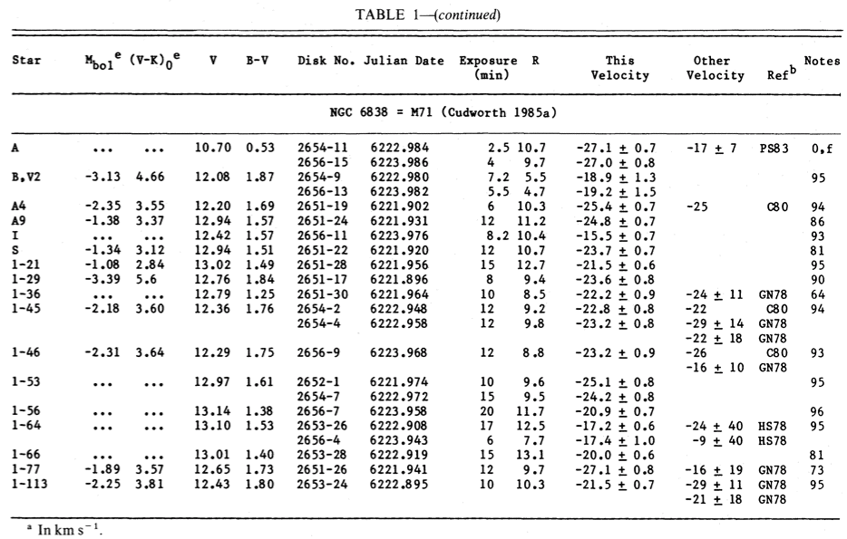

As a first step in this process, you’ll need to calculate the average velocity of these cluster members about the common center of mass. Be aware of the several assumptions and corrections you will need to make (hint: the radial velocities are with respect to the Earth).

Next, you will need to determine the average size of the cluster from the following image (note that this is a negative, so the stars appear as black spots):

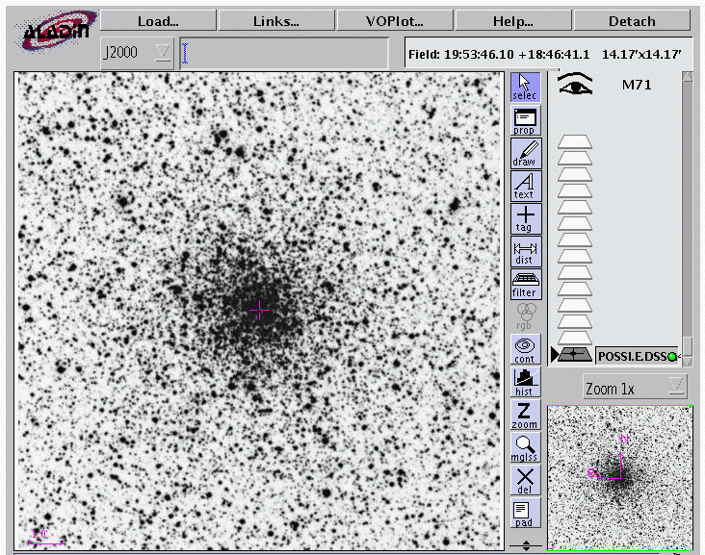

Note that the field of view is 17’ x 17’ (the pink bar in the lower left indicates 1’. Recall that 1º = 60’ = 3600”. The distance to the cluster is estimated to be 3.8 kpc. Using the information from the image and simple trigonometry, determine the size of the cluster in parsecs, and then combine your velocity and size information to estimate the mass of the cluster in solar masses. Explain all assumptions you make. (7 points)

PS2: DUE BY 5:00 pm, FRIDAY 2 OCTOBER.

- RP 5.1 (1 point)
- RP 5.2 (1 point)
- RP 5.3 (1point)
- RP 7.8 (2 points)
- RP 10.8 (2 points)
- RP 11.4 (2 points)
- Starting from the black body radiation spectrum equation, derive the Stefan-Boltzmann equation for energy flux and Wien’s displacement law for black bodies. (3 points)
- For hydrogen atoms in the Sun’s photosphere, compare the broadening of the Ha line due to Doppler broadening, natural broadening and pressure broadening. (3 points)
- Numerically calculate several random walks of units step. In this problem, use whatever numerical tools you like to compute a random walk of 100 steps. Repeat the ‘simulation’ 10 times, and plot on the same graph your results. Comment on your results, in light of our class discussion of random walks. (5 points)

